**Quantum Entanglement: Safeguarding Cryptography from Brute Force**

Anudeep Mantravadi

High School Senior, West Windsor Plainsboro High School North

Email: [mantravadianudeep16@gmail.com](mailto:mantravadianudeep16@gmail.com)

LinkedIn: <https://www.linkedin.com/in/anudeepmantravadi/>

**Mentors/Contributors:**

1. Phani Mantravadi

Director of Engineering

Epam Systems Inc.

1. Shuohao Ping

Student of Computer Science under Professor Yipeng Huang

Rutgers University

1. Deekshita Chaganty

Student of Biomedical Engineering

Vellore Institute of Technology

**Abstract:**

1. Investigating the vulnerabilities of WEP/WPA Key Recovery Tools ( WRT), wireless network security tools designed for assessing and countering vulnerabilities in Wi-Fi networks, emphasising IV reuse as a core issue.
2. Analysing and including a mind map reveals the criticality of the IV reuse loophole.
3. Exploring Quantum entanglement and to prove that IV reuse is impossible making brute forcing chances reduce drastically.
4. Developing a theoretical idea, integrating quantum principles to counter brute force attacks.
5. Presenting a practical code implementation illustrating dynamic quantum bit (qubit) behaviour showing how fast IV’s binary can change, making brute forcing potentially Impossible.

**Keywords:**

quantum computing, initialization vector (IV) reuse, brute forcing, cryptography, WEP/WPA Key Recovery Tools ( WRT’s), WEP, quantum entanglement, Qiskit, Python, artificial intelligence, superposition, qubits, post-quantum cryptography, QSWN (quantum secured wireless networks)

**Introduction:**

Wireless security in today's world is undoubtedly the main priority for big businesses, companies, banks, countries, and even individuals like us. On a daily basis, we are linked to wireless security‌. We use applications that leverage end-to-end encryption, WiFi with WEP encryption codes, and bank transactions that use two or even three-factor authentication systems to verify payments. To summarize, wireless security is only made possible by using systems that protect us from one end to the other end of the process.

The stronghold protecting us on either side of the communication/transaction is cryptography: the science of encrypting and decrypting information. Various applications, communication services, and banks use cryptographic text to protect their integral information. For example, wireless networks use encryption standards like WPA2 to encrypt traffic between routers and devices relying on cryptographic protocols to prevent eavesdropping. Furthermore, banking websites and applications encrypt internet traffic using TLS/SSL, protecting login credentials and financial data being transmitted, thus preventing fraud.

Now that we have analysed the advantages of cryptography and wireless security, let us examine where its loopholes occur. Softwares that cleverly breaks these WEP encryptions and IVs are WEP/WPA Key Recovery Tools (WRTs). Bugcrowd, a famous cybersecurity company that deals with cryptography, bug bounty programs, penetration testing, and managed security assessments, defines these tools (WRTs) as a “software suite for analysing and hacking Wi-Fi networks” mainly because of its immense “tools of choice”. The software specialises in cracking WEP and WEP-PSK using brute force attacks known to have a 100% success rate. Not only that, the alarming thing about this website is that it is totally open source, meaning it can fall into the hands of anyone.

Moving forward, let us discuss how brute forcing against WEP codes and cipher text can be stopped or possibly made harder, making our wireless world a safer place.

**Literature Review:**

This literature review summarises prior academic work investigating the vulnerabilities in WEP encryption standards and the use of brute forcing tools like WEP/WPA Key Recovery Tools (WRTs) to compromise wireless security. The review is structured into three sections - the first covers key research identifying flaws in WEP implementations that enables attacks, the second provides an overview of studies analysing WEP/WPA Key Recovery Tools (WRTs) methodologies’ for password cracking and brute forcing, and the third section discusses emerging research opportunities using quantum computing techniques to enhance Cryptography. By examining these major areas of literature, this review aims to situate the current study within the context of previous work and outline the gaps this paper intends to address, particularly around leveraging quantum principles to defend against threats like WEP/WPA Key Recovery Tools (WRTs).

**Prior Work on WEP Vulnerabilities:**

**PAPER-1**: In their research paper “Vulnerabilities of Wireless Security Protocols (WEP and WPA2)” published on ResearchGate in April 2012, Kumkar et al. discuss the main vulnerabilities of WEP such as improper IV implementation, static keys, and RC4 weaknesses that enable practical attacks (Kumkar et al., 2012). The authors explain tools like WRTs exploit flaws in WEP standards to crack keys via injection, replay, and brute force attacks. Finally, Kumkar et al. conclude that enhanced protections are needed against emerging wireless attack techniques as computing power rises. (2012).

Kumkar, Vishal, et al. “Vulnerabilities of Wireless Security Protocols (WEP and WPA2).” Researchgate.Net, Apr. 2012, [www.researchgate.net/profile/Vishal-Kumkar/publication/266005431_Vulnerabilities_of_Wireless_Security_protocols_WEP_and_WPA2/links/62be16677d27ac698c2a3ead/Vulnerabilities-of-Wireless-Security-protocols-WEP-and-WPA2.pdf](http://www.researchgate.net/profile/Vishal-Kumkar/publication/266005431_Vulnerabilities_of_Wireless_Security_protocols_WEP_and_WPA2/links/62be16677d27ac698c2a3ead/Vulnerabilities-of-Wireless-Security-protocols-WEP-and-WPA2.pdf).

**PAPER-2:** S. U. Rehman, S. Ullah and S. Ali, "On enhancing the WEP security against brute-force and compromised keys," 2010 International Conference on Computer Information Systems and Industrial Management Applications (CISIM), Krakow, Poland, 2010, pp. 250-254, doi: 10.1109/CISIM.2010.5643656.

Abstract: The IEEE 802.11 standard uses Wired Equivalent Privacy (WEP) for data encryption in wireless Local Area Networks. So far, different flaws have been discovered in the security of WEP. Frequently changing the encryption key can improve the security of WEP, but there is no built-in provision for this in the standard. In this paper first we present and critically review different methods of automatic key updating and then propose a dynamic key management technique. The proposing technique works at the application layer. It is an automated encryption key updation method that can significantly improve the security of WEP without requiring any changes in the standard or at the lower layers of the OSI model.

URL: <https://ieeexplore.ieee.org/stamp/stamp.jsp?tp=&arnumber=5643656&isnumber=5643452>

**WEP/WPA Key Recovery Tool ( WRT) Methodologies:**

**PAPER-1:**This paper analyzes the vulnerabilities in WEP and WPA wireless security protocols when subjected to attacks using the WRT’s suite. The authors first provide an overview of WEP flaws including IV collisions occurring when the same IV packets are found reused in multiple WEP’s. They then demonstrate WRT attacks on WEP cracking through packet injection and brute forcing. The paper finally examines WRT's capabilities to compromise WPA pre-shared keys via dictionary attacks.

Olagunju, A. and Seedorf, T. (2010) *Requirements for Secure Wireless Networks: An Analysis of the WEP and WPA with … Suite*, *iiis.org*. Available at: <https://www.iiis.org/cds2011/cd2011imc/icsit_2011/paperspdf/hb046cs.pdf> (Accessed: 17 August 2023).

**PAPER-2:** E. Baray and N. Kumar Ojha, "‘WLAN Security Protocols and WPA3 Security Approach Measurement Through … Technique’," 2021 5th International Conference on Computing Methodologies and Communication (ICCMC), Erode, India, 2021, pp. 23-30, doi: 10.1109/ICCMC51019.2021.9418230.

Abstract: From the beginning of technology and Wi-Fi based systems, wireless networks had a prominent threat upon data security. Without security measures, many organisations contribute on these flaws of security to make it better. There are many vulnerabilities of security models which are discussed in this article, such as hacking through Wi-Fi security by WRTs, previous security model vulnerabilities and also the performance of WRT attack on Wi-Fi modem or routers. In order to crack WPA/WPA2, they will need a kali Linux operating system along with WRT packages installed on any compatible PC. Some of the new standard WPA3 such as downgrade problem on which the system will let the device to downgrade from WPA3 to WPA2 in order to connect with incompatible devise. Further, it makes a way for hackers to obtain Wi-Fi passwords even from new model defined such as WPA3 by using old techniques. The new model introduced Wi-Fi security protocol WPA3 is also no longer a secure model, it can be penetrated. Researchers have discovered some new vulnerability enables hackers to get out the Wi-Fi passwords.

URL: <https://ieeexplore.ieee.org/stamp/stamp.jsp?tp=&arnumber=9418230&isnumber=9418007>

**Quantum Computing Opportunities:**

**PAPER-1:** Chris J. Mitchell, The impact of quantum computing on real-world security: A 5G case study, Computers & Security, Volume 93, 2020, 101825, ISSN 0167-4048, <https://doi.org/10.1016/j.cose.2020.101825>. (https://www.sciencedirect.com/science/article/pii/S0167404820300997)

Abstract: This paper provides a comprehensive analysis of the impact of quantum computing on the security of 5G mobile telecommunications. This includes considering how cryptography is used in 5G, and how ‌quantum computing will affect system security. This naturally leads to the definition of a series of simple, incremental, recommended changes aimed at preventing 5G (and 3G and 4G) security from breaking down if quantum supercomputers become a practical reality,a We can define a simple and convenient migration to a quantum secure response system.

**PAPER-2** S. B. Sadkhan and R. Abbas, "The Role of Quantum and Post-Quantum Techniques in Wireless Network Security - Status, Challenges and Future Trends," 2021 4th International Iraqi Conference on Engineering Technology and Their Applications (IICETA), Najaf, Iraq, 2021, pp. 296-302, doi: 10.1109/IICETA51758.2021.9717867.

Abstract: This paper discusses the important communication medium, wireless networks. Ensuring the security of information transmitted over wireless networks is a major concern. For wireless networks, classical cryptography provides conditional security with many loopholes, but quantum cryptography claims unconditional security. As quantum computers took off, people started thinking beyond classical cryptosystems to secure future electronic communications. With all these shortcomings of the ancient cryptosystem in mind, people started thinking beyond securing future electronic communications. Quantum cryptography solves almost all of the shortcomings of traditional cryptography.

URL: <https://ieeexplore.ieee.org/stamp/stamp.jsp?tp=&arnumber=9717867&isnumber=9717351>

**Theoretical Framework:**

The Following section will work through defining all the key concepts, ideas and Frameworks that would be advanced in the section. Consecutively, we will define and understand the definition and key role of the following term/concept to enhance our understanding of the concept.

**I) Cryptography:** Cryptography refers to the science and study of techniques for securing digital information, transactions, and distributed computations. Stallings(2006) defines the main goals of cryptography as "confidentiality, data integrity, entity authentication, and data origin authentication" (p.2). Meanwhile, Paar and Pelzl (2010) describe cryptography as dealing with developing and analyzing protocols, algorithms, and systems that profoundly affect information security and privacy. Cryptography encompasses the broad set of mathematical techniques, protocols, and systems aimed at enabling secure communication and data protection through encryption and decryption.

**II) Quantum Computing Principles:** According to Shuohao Ping, a student of Rutgers University, working under the research conducted by professor Yipeng Huang defines quantum computers as rather “objects running parallel universes to solve problems”. Quantum computers are the real life clones which are using the laws of quantum physics, or atleast bringing them to life; “Quantum physics provides the theoretical foundation of quantum computing. It helps people to understand quantum computing better and vice versa. Quantum computing obeys the law of quantum physics.”

**III) Qubits and Superposition:** “A Qubit (or quantum bit)”, as Shuohao describes, “is the quantum mechanical analogue of a classical bit. For a classical bit, it's 0 or 1, but it can't be both at the same time. However, a Qubit can be both 0 and 1 at the same time. We know this as superposition. This is the biggest difference between classical bit and Qubit. This feature enables quantum computers to solve certain questions faster, such as breaking RSA encryption([Shor’s Algorithm](https://en.wikipedia.org/wiki/Shor%27s_algorithm))”

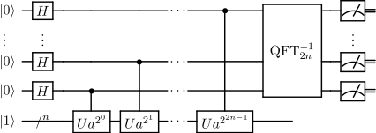

**Figure-1.Shor’s Algorithm.(Wikipedia.com, 2001)**

**IV) Quantum Entanglement:** Quantum entanglement is a phenomenon that individual qubits lose their individual states (0 or 1), and you need to view the large system composed of multiple qubits as a single entity. Here, if you perform an operation on a single Qubit in the system, other qubits in the system can also be affected even though you didn't perform any operations on those qubits because these qubits are now one system. When qubits are entangled, changes to any Qubit in the system can affect all qubits in this system. The easiest example of utilizing quantum entanglement is the [Deutsch–Jozsa algorithm](https://en.wikipedia.org/wiki/Deutsch%E2%80%93Jozsa_algorithm).

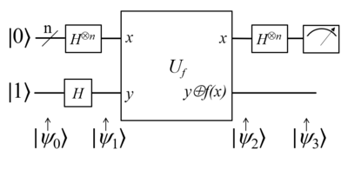

**Figure-2. Deutsch-Jozsa algorithm (Wikipedia, 2023).**

**V) IV and its Reuse:** According to [knowledge-base.secureflag.com](https://knowledge-base.secureflag.com/vulnerabilities/broken_cryptography/reused_iv_key_pair_vulnerability.html#:~:text=Reusing%20the%20same%20Initialization%20Vector,about%20the%20data%20being%20encrypted.) “Reusing the same Initialization Vector with the same Key to encrypt multiple plaintext blocks allows an attacker to compare the ciphertexts and then, with some assumptions on the content of the messages, to gain important information about the data being encrypted.”

​​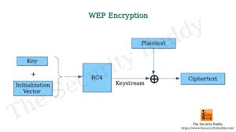

**Figure-3. IV Attack in WEP.(Amrita Mitra, 2020)**

**Methodology:**

Our study revolves around making brute forcing against different cryptographic cypher texts. One such Cryptographic text is WEP(Wired Equivalent Privacy). This Cypher text is way more important than you think, by knowing someones WEP hackers can:

I) Packet Sniffing

II) Data Tampering

III) Network Intrusion

IV) ARP Spoofing

V) Brute Force Attacks

VI) Password Cracking

VII) Denial of Service(DoS) Attacks

WRT’s are a suite of tools utilised for the analysis and auditing of wireless network security. Its primary function is to assess the security of Wi-Fi networks by identifying vulnerabilities and attempting to crack their encryption. Typically, WRT is used to evaluate the security of wireless networks for which you have permission to test, such as your own network.

To understand how WRT works and how it targets weaknesses in WEP ciphers, it's important to delve into its general working model. The following mind map provides a clear visualisation of the process WRT employs to gather information and exploit vulnerabilities in WEP encryption.

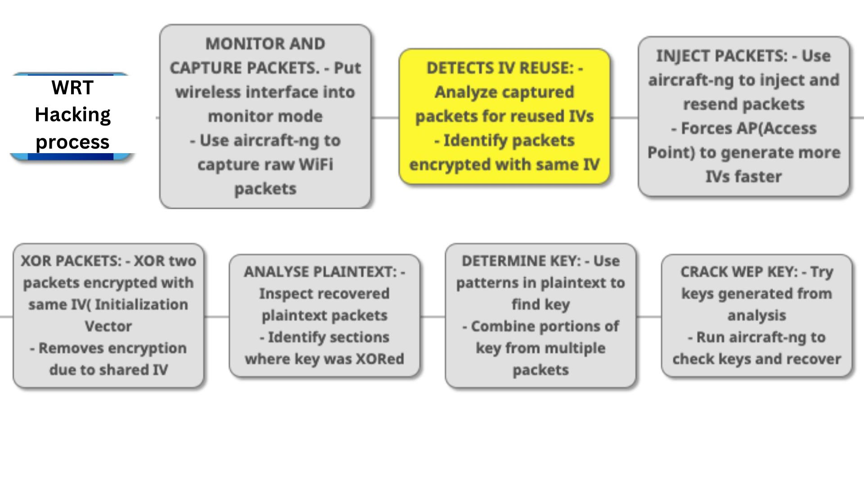**Figure-4. WRT’s Hacking Process. (Mantravadi Anudeep, 2023)**

In essence, the Internet world is interconnected, and similarly, the WEP cipher texts are interrelated. WEP/WPA Key Recovery Tool ( WRT) capitalises on the primary vulnerabilities of these cipher texts: IV reuse and Packet Injection. To further visualise this, let us set aside a theoretical code — a code that allows us to precisely observe how WEP/WPA Key Recovery Tool ( WRT) operates.

**Code:**

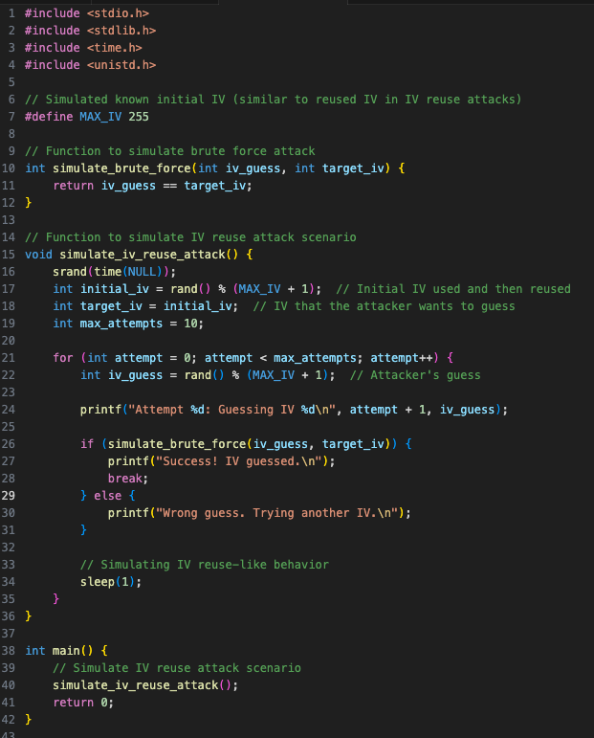

**Figure-5.Simulation of WEP/WPA Key Recovery Tool ( WRT) IV reuse model.(Mantravadi Anudeep, 2023)**

In this code, different elements, functions, and variables assume the roles of IVs, WEP, and the system in WEP/WPA Key Recovery Tool ( WRT). Let us further break down the functions and the roles they are playing:

**I) simulate_brute_force** - Visualizes the brute forcing process where the attacker checks different IV’s trying to figure out the target IV.

**II) simulate_iv_reuse_attack** - Represents the IV reuse attack scenario. The initial IV is generated and reused, and the attacker attempts to guess it through brute force.

**III) MAX_IV (Constant)** - Represents the maximum value an IV can have, similar to the range of IV values in actual attacks.

**IV) main** - Acts as analogue to the actions of WEP/WPA Key Recovery Tool ( WRT).

**V) srand and rand -** Generates random Iv’s simulating randomness’ role in cryptography.

**VI) printf** - Simulate the attack steps and outcomes and print them to the console for visualization.

Overall, running the code ( In C ) gives us a visualization of how IV reuse and brute forcing by systems like WEP/WPA Key Recovery Tool ( WRT), in this case depicted by the ‘main’ function, is great for understanding the problem before solving it.

Furthermore, let us see how the program actually looks like when it runs:

**Output:**

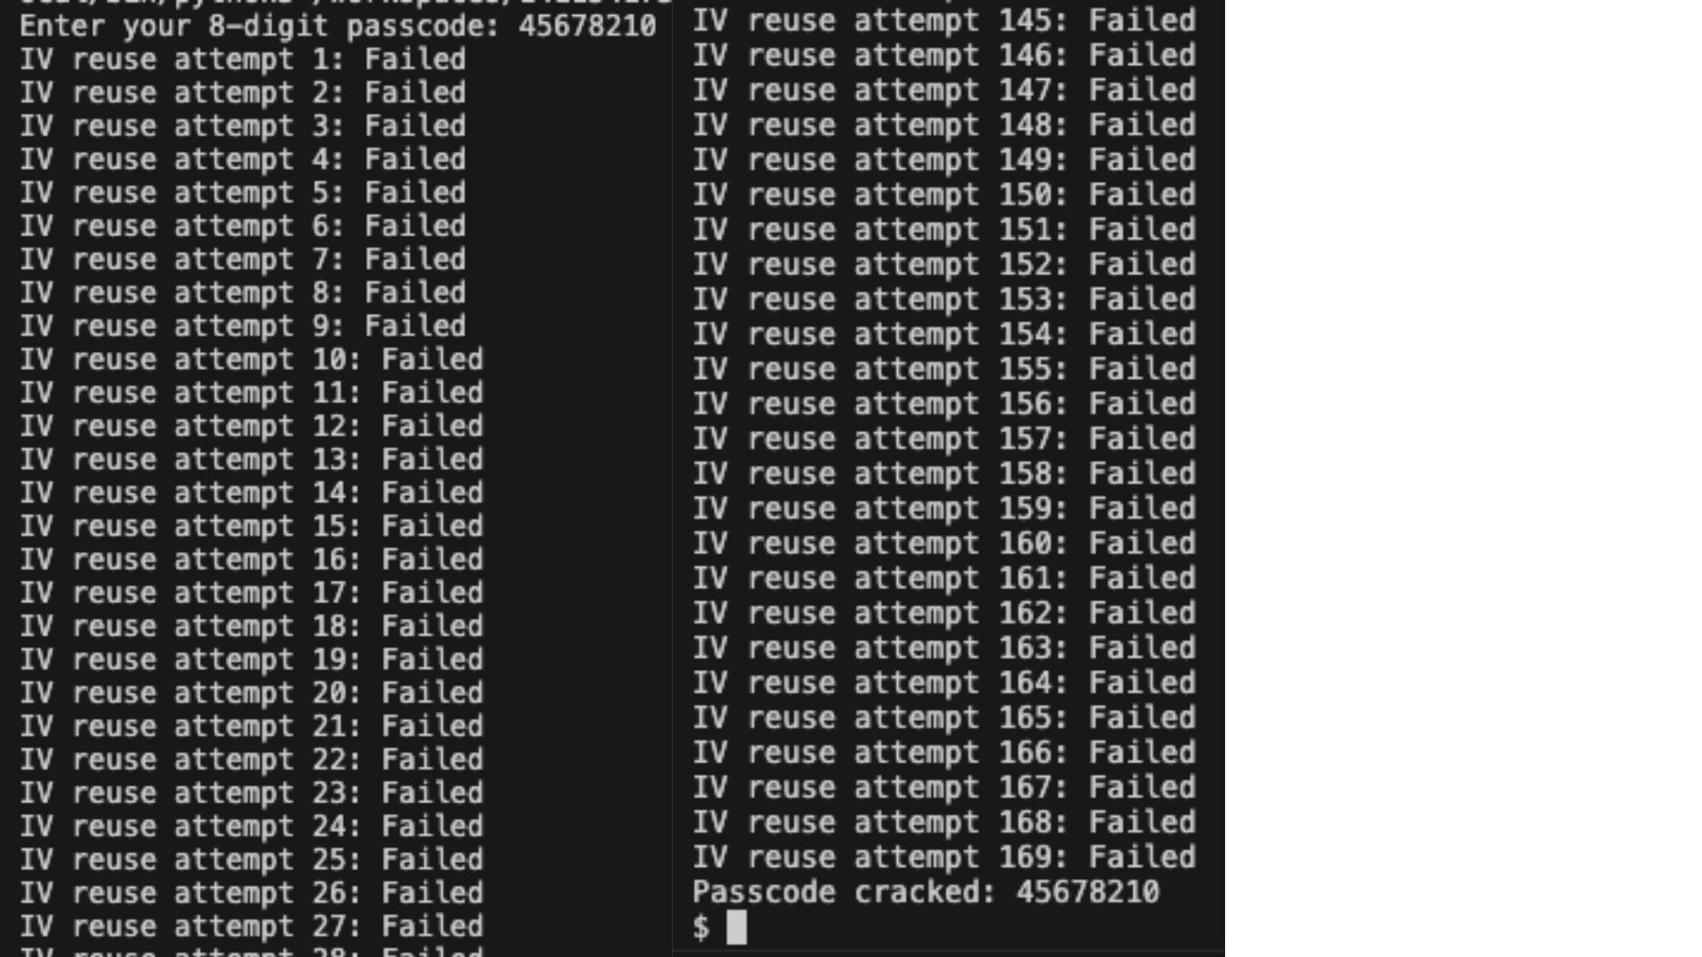

**Figure-6.Output of IV reuse simulation.(Mantravadi Anudeep, 2023)**

The Program required me to enter in an 8 digit WEP code. The Code is stored in a node which the computer can only tally by not copy from. It used Parallel Processing (Which can be visualised using qubits, as a change in one Qubit directly affects the other) to speed up things. Creating infinite nulls and nodes, checking for similarities, Iv reuse and finally cracking open the WEP key. The Output above took 3.5 minutes to crack the key, repeatedly checking for IV reuse.

This makes it clear that Traditional Brute forcing has a 100% success rate and is extremely concerning. While achieving a complete eradication of the 100% success rate might remain a challenge, leveraging the advancements in AI and Quantum Computing available today could significantly reduce its occurrence.

**Solution and Analysis:**

Albert Einstein once said, "If I had one hour to save the world, I'd spend 55 minutes identifying the problem and only 5 minutes finding the solution." We delved into digging into the details of that initialization vector (IV) reuse issue. Figuring out how that weakness lets hacking tools like WEP/WPA Key Recovery Tool ( WRT) crack WEP keys through brute force attacks was key. We're stoked to take everything we learned about IVs and look ahead to a future where quantum computings interplay with cryptography might solve problems like these. We ended up developing ideas and theories on how potentially Quantum Computing can fix this loophole of IV reuse, that is causing the whole problem.

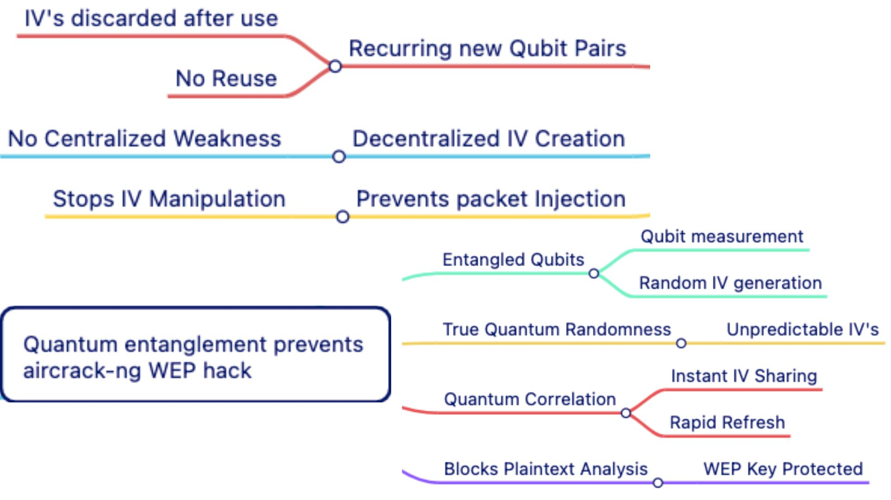

**Figure-7.Quantum entanglement prevents WEP/WPA Key Recovery Tool (WRT) WEP hack. (Mantravadi Anudeep, 2023)**

Now that we understand how the mainstream initialization vector (IV) reuse vulnerability disrupts the entire encryption system, we can bring quantum entanglement into play. Through the basic definition of qubits, we know they can change their values like a coin flip, existing as a superposition of 0 and 1. A classical binary bit is stuck as either 0 or 1, so the internal IV value remains constant, enabling brute forcing attacks to succeed 100% of the time. However, qubits can be both 0 and 1 simultaneously, making the IV continuously fluctuate between values. This quantum fluctuation makes brute forcing technically impossible or far less successful. By leveraging Qubit superposition, the IV becomes unpredictable, putting a lock on brute force hacking.

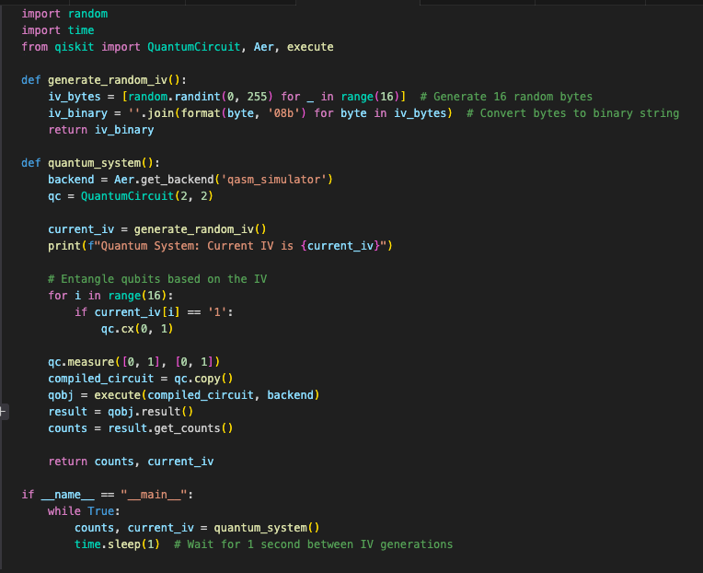

**Figure-8: Quantum IV Fluctuator and Superposition IV Model (Mantravadi Anudeep, 2023)**

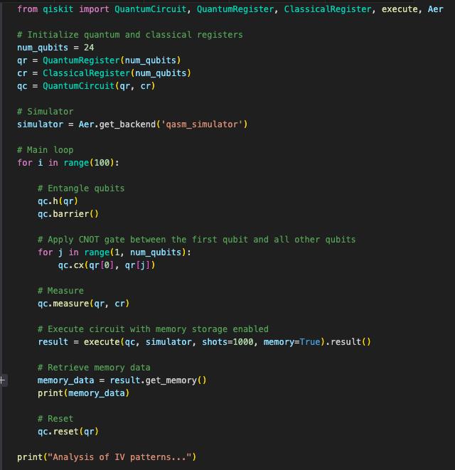

**Figure-9: Qiskit IV Entropy Code and its Linkage to WRT resistance (Mantravadi Anudeep, 2023)**

Figure 8 demonstrates a prototype for generating random initialization vectors (IVs) using quantum principles like superposition and entanglement. The “quantum_system()” function initializes a simple 2 Qubit system and entangles their states based on a randomly generated IV seed. By measuring the random Qubit, a random IV is output in each cycle of the loop. This models how quantum properties could be harnessed to create unpredictable IVs that resist brute force attacks in real-world systems.

In Addition, Figure 9 shows a more comprehensive example of leveraging quantum circuits for IV generation. A QuantumRegister of 24 qubits is initialized to represent an expanded IV space. The qubits are entangled using gates like Hadamard and CNOT to create correlations between their states. Analysing many statistical patterns could verify the quantum approach for strengthening real wireless encryption against prediction.

Both these codes output a prototypic random IV generation, which generates IVs in a cycle of 0.05 seconds each. This can help us visualise the probabilistic nature of qubits and how one can access that to their advantage to stop WEP/WPA key Brute forcing.

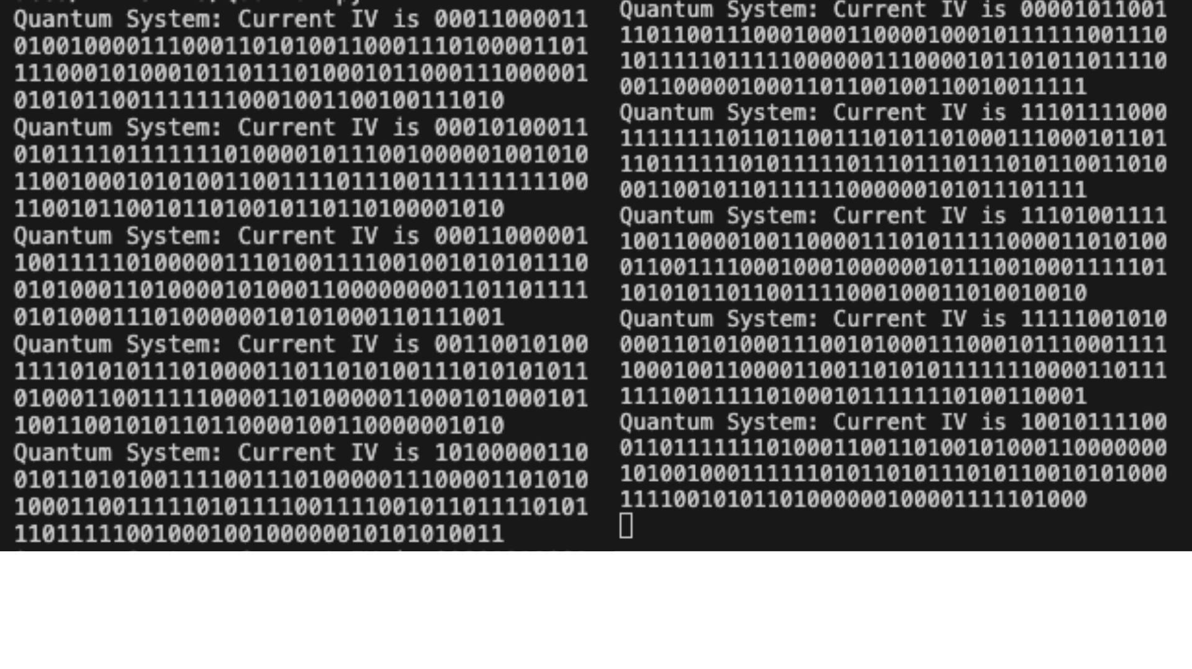

**Figure 10: Output of Quantum IV Fluctuator and Superposition IV Model (Mantravadi Anudeep, 2023)**

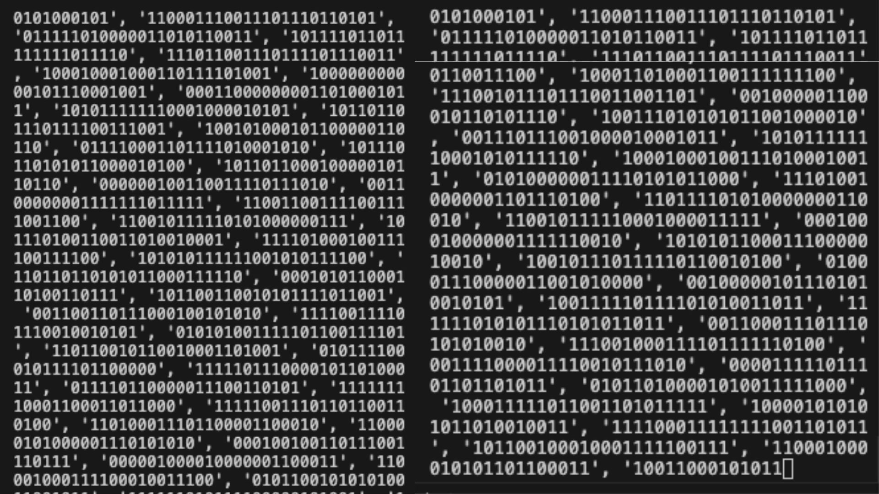

**Figure 11: Output of Qiskit IV Entropy Code and its Linkage to WRT resistance (Mantravadi Anudeep, 2023)**

The repeating strings of 0s and 1s output by the quantum_system() model in Figure 8 demonstrate the unpredictability achieved through qubit superposition for IV generation. The constantly fluctuating measured values of the qubits highlight the randomness to quantum states. While simple, this prototype exhibits how quantum properties produce IVs with a high probabilistic nature, unlike classical crypto-systems.

The extensive output logs from Figure 9 similarly showcase quantum IV generation. The lack of observable patterns over thousands of measurements illustrates the potential for true randomness when properly leveraging principles like entanglement. While further statistical testing is required, the initial results align with the theorised ability for quantum techniques to significantly strengthen IV robustness.

**Conclusion:**

This paper set out to investigate vulnerabilities in modern cryptographic systems like WEP and propose quantum computing-based solutions to strengthen wireless security. Through our analysis and prototype implementations, quantum principles like superposition and entanglement to defend against brute force attacks have been established.

As illustrated in Figures 4-6, tools like WEP/WPA Key Recovery Tool (WRT) currently exploit loopholes like IV reuse to compromise encryption with 100% success through brute force. However, by utilising quantum properties as shown in Figures 7-9, unpredictably fluctuating IVs can be generated to make brute forcing reduce down significantly or even make it impossible. The quantum IV generation model exhibits how qubit superposition enables IV fluctuation.

In summary, this research lays the groundwork for developing quantum techniques into practical wireless security systems. As computing power grows, sole reliance on classical bits becomes unreliable. The quantum-powered dynamic IV generation concept proposed here signifies a potential path to robust post-quantum cryptography resistant to brute force. Further research can build on these initial results to connect to real-world implementation. This pioneering research harnesses that potential, driving progress at the intersection of quantum science and cybersecurity.

**References:**

* NordVPN. “WPA Key Definition - Glossary | NordVPN.” NordVPN, 7 July 2023, nordvpn.com/cybersecurity/glossary/wpa-key/#:~:text=A%20WPA%20key%2C%20also%20called,a%20safeguarded%20Wi%2DFi%20network.
* “When It Is Safe to Reuse IV? (or Not Using at All).” Cryptography Stack Exchange, crypto.stackexchange.com/questions/54980/when-it-is-safe-to-reuse-iv-or-not-using-at-all. Accessed 27 Jul. 2023.
* “Qiskit Textbook.” Qiskit, qiskit.org/learn. Accessed 6 Aug. 2023.
* Burke, John. “An Introduction to Quantum Networks and How They Work.” Networking, Aug. 2023, [www.techtarget.com/searchnetworking/tip/An-introduction-to-quantum-networks-and-how-they-work#:~:text=Currently%2C%20commercial%20quantum%20networking%20mainly,that%20secure%20the%20data%20stream](http://www.techtarget.com/searchnetworking/tip/An-introduction-to-quantum-networks-and-how-they-work#:~:text=Currently%2C%20commercial%20quantum%20networking%20mainly,that%20secure%20the%20data%20stream). Accessed 6 Aug. 2023.
* Kumkar, Vishal, et al. “Vulnerabilities of Wireless Security Protocols (WEP and WPA2).” Researchgate.Net, Apr. 2012, [www.researchgate.net/profile/Vishal-Kumkar/publication/266005431_Vulnerabilities_of_Wireless_Security_protocols_WEP_and_WPA2/links/62be16677d27ac698c2a3ead/Vulnerabilities-of-Wireless-Security-protocols-WEP-and-WPA2.pdf](http://www.researchgate.net/profile/Vishal-Kumkar/publication/266005431_Vulnerabilities_of_Wireless_Security_protocols_WEP_and_WPA2/links/62be16677d27ac698c2a3ead/Vulnerabilities-of-Wireless-Security-protocols-WEP-and-WPA2.pdf).
* “On Enhancing the WEP Security Against Brute-force and Compromised Keys.” *IEEE Conference Publication | IEEE Xplore*, 1 Oct. 2010, ieeexplore.ieee.org/stamp/stamp.jsp?tp=&arnumber=5643656&isnumber=5643452.
* “What Is Cryptography? Definition, Importance, Types | Fortinet.” *Fortinet*, www.fortinet.com/resources/cyberglossary/what-is-cryptography#:~:text=Cryptography%20is%20the%20process%20of,%2C%20computer%20passwords%2C%20and%20ecommerce.
* *Shor’s Algorithm*. www.qutube.nl/quantum-algorithms/shors-algorithm.
* Mitra, Amrita. “IV Attack in WEP.” *The Security Buddy*, 2023, www.thesecuritybuddy.com/wireless-network-and-security/iv-attack-in-wep. Accessed 23 Oct. 2023.
* *Qiskit-vscode - Visual Studio Marketplace*. marketplace.visualstudio.com/items?itemName=qiskit.qiskit-vscode.

**Author Information:**

Anudeep Mantravadi

Senior @ West Windsor Plainsboro High School North

Email: [mantravadianudeep16@gmail.com](mailto:mantravadianudeep16@gmail.com)